Abstract
This experiment investigated the thermodynamic relationship between the temperature and pressure of a gas at a constant volume, specifically testing Gay-Lussac’s Law. Using smartphone barometers and the Phyphox app, pressure data was collected as air inside a sealed mason jar cooled in a refrigerated environment. The results demonstrated a linear decrease in pressure corresponding to the temperature drop, with an experimental slope of 4.67 hPa/K. Analysis yielded an experimental mole count of 0.2005 mol, resulting in a 38.88% percent error compared to the theoretical mean of 0.1445 mol. Despite this discrepancy, the high linear correlation confirms the efficacy of smartphone sensors for observing fundamental gas laws

Introduction
The experiment is motivated by the physical principle that for a fixed mass of gas at a constant volume, the pressure is directly proportional to its absolute temperature. This relationship is governed by the Ideal Gas Law:
$$pV=nRT$$
Where $p$ is pressure, $V$ is volume, $n$ is the number of moles, $R$ is the ideal gas constant (8.314 $J/mol⋅K$), and $T$ is temperature. At a constant volume, the relationships simplified to Gay-Lussac’s Law, predicting that a plot of pressure versus temperature will yield a linear trend where the intercept should theoretically be zero at absolute zero.

Experiment
- Apparatus:
  - Smartphone barometers (iPhone and Android)
  - Phyphox App
  - Mason Jar (4.2 L)
  - Fridge
- Procedures:
- Data Extraction: Pressure data was collected at a sample rate of 1 Hz using the Phyphox app. Android data was under-sampled during post-processing to match the iPhone sample size for consistent visualization. Only 4 out of 6 phones recorded valid data.
- Experimental Setup: Six smartphones were placed inside a sealed mason jar to maintain a constant gas volume.
- Cooling Phase: The jar was placed in a fridge for approximately 15 minutes (900 samples) to allow the internal air temperature to decrease from an initial $T_{0}=23°C$ (296 K) to $T_{f}=20°C$ (293 K).
- Volume Calibration: The effective gas volume $V_{gas}$ was calculated by subtracting the volume occupied by the six phones from the total jar volume.

Data and Analysis

Volume Calculation
The total volume of the jar was 4200 mL ($0.0042 m^{3}$). The volume of the phones ($V_{phones}$) was estimated using the dimensions of an iPhone 16 Pro Max ($0.000626 m^{3}$ for 6 units).
$$V_{gas}=V_{jar}-V_{phones}=0.0042 m^{3}-0.000626 m^{3}=0.003572 m^{3}$$

Raw Data
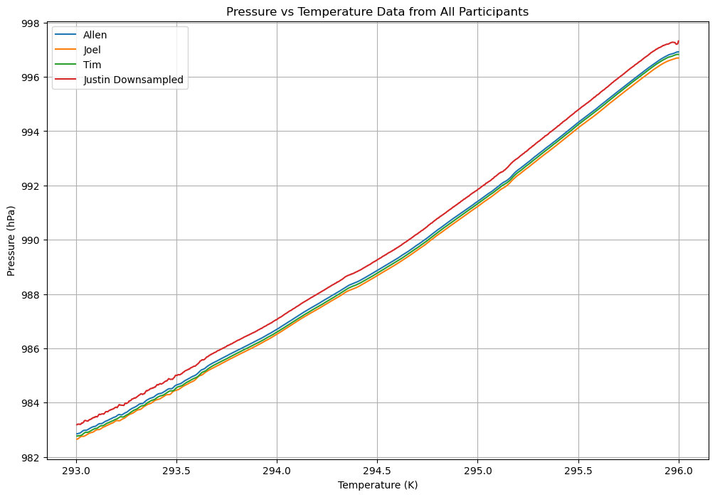
Figure 1: Raw data from
- Justin’s Android data was under sampled to match sample size of iPhone data for visualization and calculation purposes.
- The android barometer appears to be calibrated differently from the iPhone’s (Allen, Joel, Tim)

Trend Analysis
As the temperature decreased, the internal pressure dopped linearly, confirming direct proportionality. Using the formula $\frac{P_{f}-P_{0}}{T_{f}-T_{0}}$, the experimental slope was determined.
- Experimental Slope: $4.67 \text{ hPa}\text{/}\text{k}$
- Y-intercept: -385.4775
- Standard Deviations: 0.06 hPa and 0.07 hPa
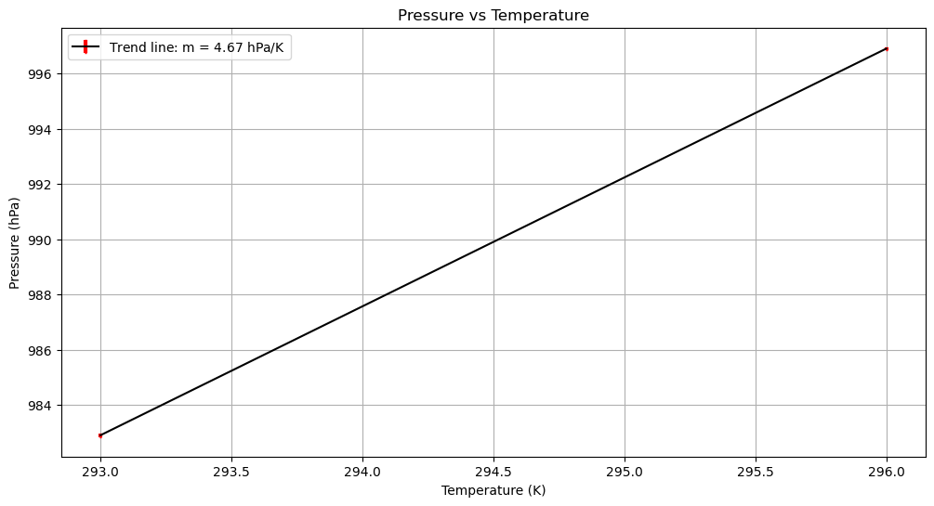

Results
The number of moles was calculated using the rearranged Ideal Gas Law:
$$n=\frac{pV}{RT}$$
- Experimental Moles ($n$): 0.2005 mol
- Theoretical Moles (Initial): $n_{0}=\frac{p_{0}V}{RT_{0}}$
- Theoretical Moles (Final): $n_{f}=\frac{p_{f}V}{RT_{f}}$
- Theoretical Moles Mean: $0.1445 \text{mol}$
- Percent Error: $38.88$

Discussion
Error Analysis and Discrepancies
The significant percent error (38.88%) suggests that the experimental estimation of the number of moles was higher than theoretical predictions. This is likely attributed to inaccurate measurements of the phone volumes, as dimensions for only one phone model were used to represent all six devices in the jar. Furthermore, the y-intercept of -385.4775 deviates from the theoretical intercept of 0, which represents the point of zero pressure at absolute zero temperature.

Conclusion
The experiment successfully validated the linear relationship between temperature and pressure as predicted by Ideal Gas Law. While a 38.9% error was observed in the mole calculation, the high correlation of the pressure-temperature slope proves that a smartphone and a common mason jar are effective instruments for observing fundamental thermodynamic behaviors

